# Introduction:

WEI™ is a middleware product designed to mitigate OFAC risks associated with Chinese Telegraphic Codes (CTC) for your institution. WEI™ is designed to monitor, screen, reconcile, audit and generate reports on messages that contain CTC. WEI™ intercepts incoming messages, automatically identifies the presence of CTC and translates them to English, before sending transactions for OFAC screening. WEI™ manages the workflow seamlessly so that no changes are required to the payment system or the OFAC filtering software.

The following are the main components of WEI™:

WEI™ Service:A windows service that automatically identifies CTC within messages. The following are the various components:

Message Watcher:This component watches either MQ or file system to monitor for messages. The option whether to monitor MQ or file system will be stored in the WEI™ database. Once a message is received, a new request will be created in WEI™ database and a unique reference number is assigned to that particular message. The service currently supports MQ and file driver interfaces. The option to specify which interface should be used is specified in WEI™ database. The following message formats are currently supported:

* SWIFT
* XML
* FEDWIRE
* PlainText

The option to specify a message format is specified in WEI™ database. If the service is not able to find the appropriate message format, the message format will be default to plain text.

Message Converter:This component identifies if a message contains CTC codes. If the message has CTC codes, the translation from CTC to English will take place as a two step process:

* CTC to Chinese (Simplified or Traditional depending on the configuration)
* Chinese to English using third party translators like Google or Bing. Only the Chinese characters will be sent to translators for translation. The English translation will be appended to the original message before sending the translated message for Watchlist filtering screening process and the status on the message in the database will be updated accordingly.

WEI™ Workflow:

The following diagram depicts the WEI™ workflow:



## WEI™ Service Configuration file:

The configuration required for the WEI™ service to function properly will be defined in the configuration file. This section explains the elements that are defined in the configuration file and their functionality:

**Chips** Element: This element will be configured if the message type format is FEDWIRE. The attribute “translateAllTags” will specify if all the tags in the message will have to be looked for CTC codes for translation.

**Tags** Element: This element defines the collection of tags when message type format is “FEDWIRE” that can be defined for CTC code lookup. The message translator component will look for any possible CTC codes within the tags defined and translates them to English for each tag.

**Logging** Element: This element defines the configuration settings for detailed logging and the location where the log file will be written to. Depending on the severity of the errors, the system can be configured to be written to Windows Event viewer with a severity message associated.

**Wei** Element: The following attributes can be specified:

**ThreadPoolSize** – This attribute specifies the thread pool size for handling the messages concurrently on a real time basis.

**applyCustomName** – This attribute indicates whether custom text specified in “CustomName” attribute value, should be appended to the translated text. If the value is set to true, then the custom text will be appended to the translated text and sent to OFAC filtering software.

**Translator** Element: The translator element specifies the rule attributes for identifying telegraphic in a message. In addition, this element also specifies the mapping file (“Chinese Traditional” or “Chinese Simplified”) that will be used to convert the telegraphic codes to corresponding Chinese characters. The element has the following attributes:

**CurrentTranslationProvider**: This attribute specifies what the current translator should be. The default value is “Google”.

**CurrentLanguage**: This attribute specifies what the current language for translation should be. The values are “Chinese Simplified “or “Chinese Traditional”. The default is “Chinese Traditional”.

**CTCDeterminingCount**: This attribute specifies the number of occurrences of sequence of 4 digits separated by a space. The default value is 2.

**NoOfRetries**: This attribute specifies the number of retries on the message when there is an error while performing the translation. The default value is 5.

**CTCAllowedCharacters**: This attribute specifies the characters that will be allowed between the sequences of 4 digits.

**MapFiles** Element: This element defines the collection of Chinese Translation Map files that can be used.

**Providers** Element: This element defines a collection of translation providers.

**TranslationExceptions** Element: This element defines a collection of exceptions that can be defined within the system. Define an exception when you do not want Phone numbers, account numbers etc, that look like CTC to be translated to English.

**Parsers** Element: This element defines a collection of parsers that will be used depending on the message format. If the message format is XML, then XML parser can be specified.

**Proxy** Element: This element will be specified if there is a proxy authentication required when connecting to Internet. If proxy server is not specified, then this configuration can be ignored.

**System.ServiceModel** Element: This configuration will be required for “WeiMonitoring” service manager. The service manager is used to start/pause or stop the Wei Service.

# WeiMonitoring Service Manager:

The Service Manager is used to start/Stop and pause WEI™ service. If there are messages that are currently being processed by WEI™ service from the message queues, clicking on the “Show Statistics” button will display the statistics of the messages. The service will not be paused or stopped unless are the messages in the message queues are processed. The “Force Shutdown” button will forcefully shut down the service. Any messages that are in the queues will be lost.

# WEI™ Dashboard:

WEI™ Dashboard is a web application that provides the ability to view messages that are processed through WEI™ Service on a real time basis. WEI™ dashboard also provides a mechanism for reconciling the messages that have been processed through the service for a given date or for date ranges.

The Dashboard by default will list all the messages with their current status that are either processed or currently being processed by WEI™ service for the current date. The grid that displays the messages will be refreshed based on the value set in the configuration file. The following message information will be displayed on the screen:

**ID** – Request ID, which is a unique identifier associated with a request.

**Message ID** – unique identifier associated with a message.

**Interface Name** – Name of the interface. Ex File Interface or MQ Interface.

**Current Status** – Current status of the message. Possible values would be

* **UnProcessed**  - The message from payment system was picked up by Wei Translator Service.
* **Translated** – The message with CTC was translated to English
* **SentForOFACCheck** – The message with CTC was translated to English and sent to OFAC Filtering software for OFAC check.
* **OFACResponseRecieved** – The message was OFAC checked and a response was received. The response could be ‘OK’ or ‘Confirmed’ (OFAC hit was confirmed).
* **Processed** – The message was OFAC Checked and found to be clean to be picked up by the payment system

**OFAC Violation** – Specifies if there was an OFAC Violation. The possible values are:

* **Confirmed** - OFAC violation has been confirmed in OFAC Filtering Software
* **OK** – OFAC violation has been waived in OFAC Filtering Software
* **UnProcessed** – OFAC Violation in

**Create Date –** Date and time when the request was created.

**Modified Date –** Date and Time when the request was modified.

The below screenshot displays messages with current statuses as of the current date.

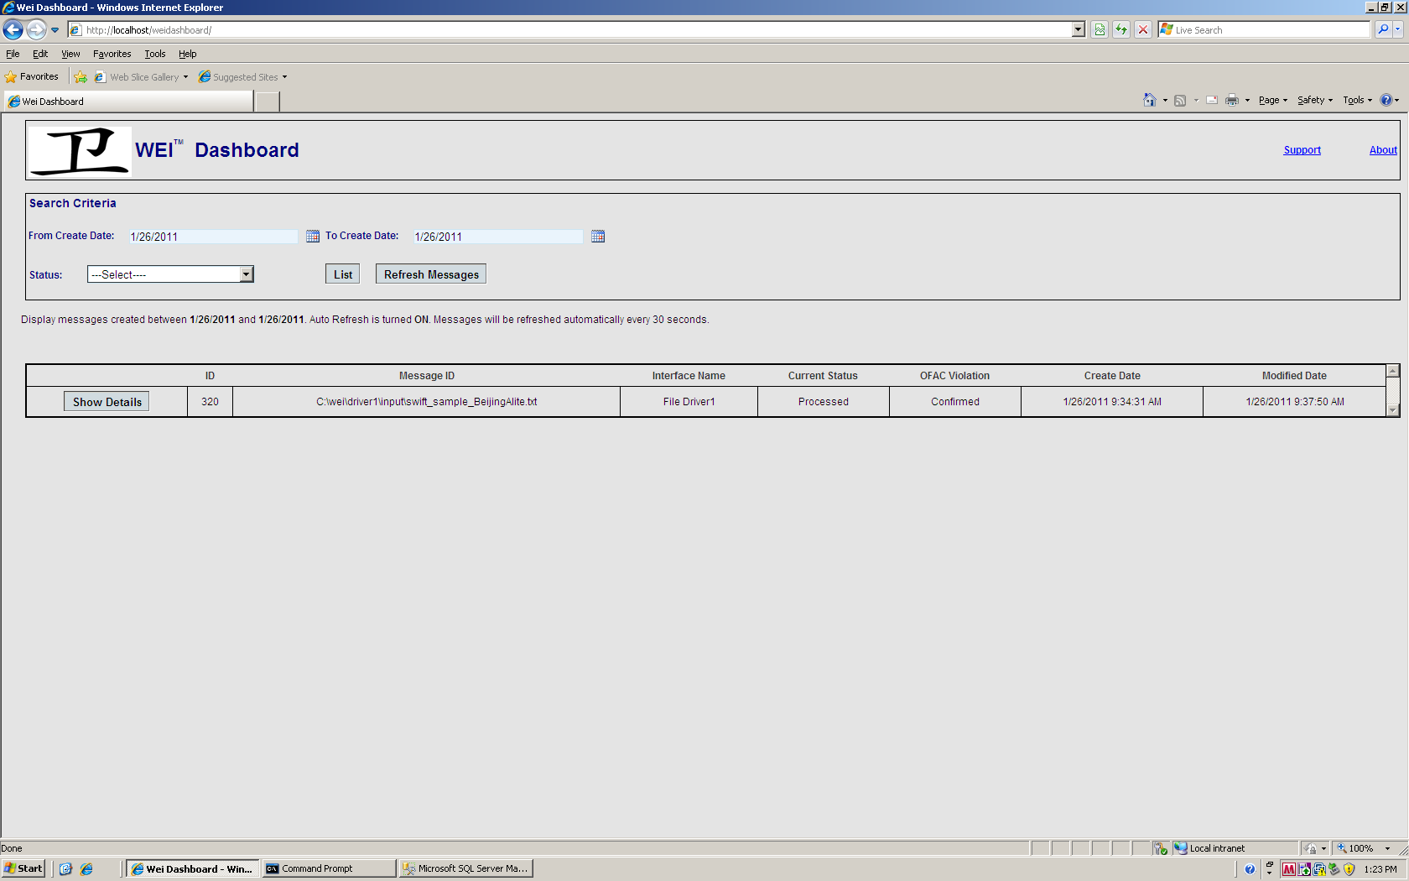

**Wei Dashboard to display messages for current date. Grid Auto Refresh turned on by default**

The Dashboard also provides the ability to search messages based on date ranges and message statuses. The grid refresh will be automatically turned off, when the user provides search criteria and clicks on the “List” button. A message will be displayed showing the selected criteria and that the grid refresh is turned off. In order to turn on the grid refresh, the user will have to click on “Refresh Messages” button.

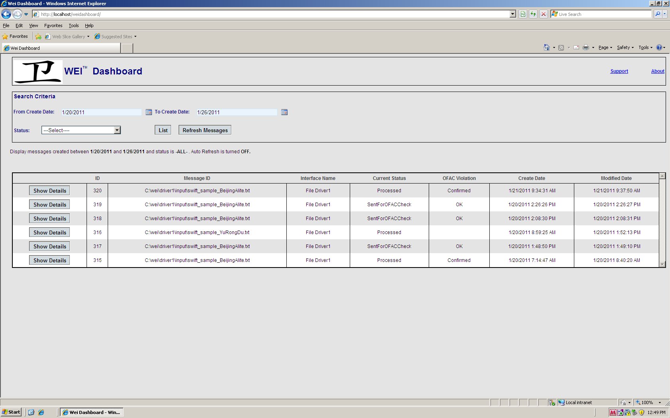

**Wei Dashboard displays messages that have been specified with Search Criteria. Grid Refresh will be turned off.**

Clicking on the “Show Details” button will display the message details popup screen.

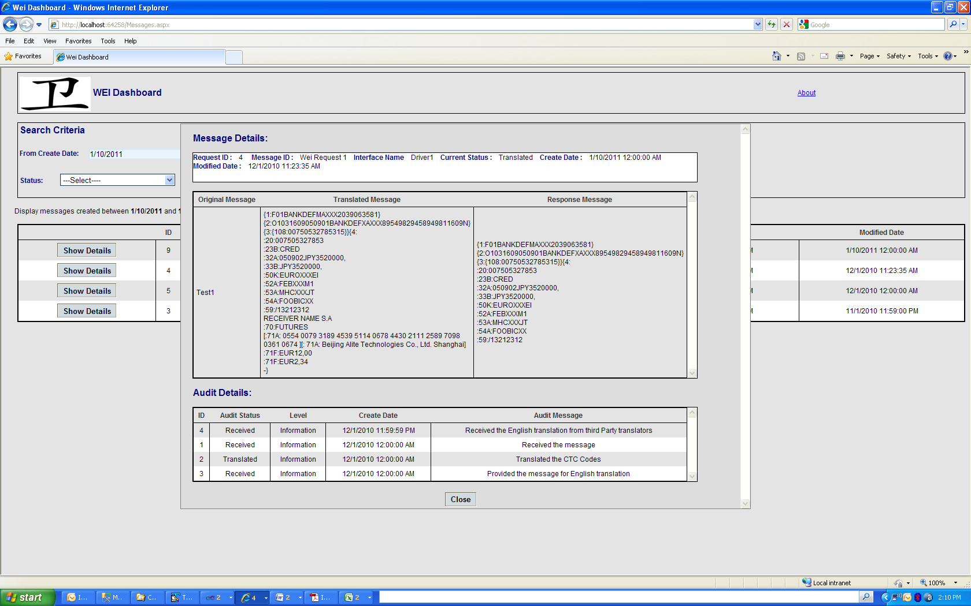

The top grid displays the Original Message, Translated Message and “Response Message”. The “Original Message” represents the message that was received from the external system(s). The “Translated Message” represents the message that has been translated to English, corresponding to CTC. The English translation will be displayed next to the Chinese Telegraphic codes. The “Response Message” will display the message that has been altered to include the OFAC Matches info into the original message.

The Audit Details grid will display the Audit information for a message for a particular request. The following columns will be displayed:

**ID –** Unique Identifier associated with message

**Audit Status –** Status of the message

**Level –** indicates the severity of the message. Possible Values are:

* Information
* Debug
* Error

**Create Date –** Date when the message was created.

**Modified Date -** Date when the message was modified.

**About:** The About screen will display the following information:

